**ACKNOWLEDGEMENT**

**I feel proud to present my project in**

**Computer science**

**On**

**“CRIMINAL MANAGEMENT”**

**This project wouldn’t have been feasible without the proper guidance of my computer science teacher**

**“Mrs. GURUVINDER KAUR”**

**I want to thank her for guiding me on a step by step basis and ensuring that I completed my project with ease.**

**Rigorous hard work has been put in this project to ensure that it proves to be the best.**

**CERTIFICATE**

***This is to certify that the project on***

***“CRIMINAL MANAGEMENT”***

***Contains the authentic work done by***

***“VANSHIKA JAIN”***

***Of***

***Class XII A2***

***Of***

***“S.D PUBLIC SCHOOL”***

***Under the guidance of***

***“GURUVINDER KAUR”***

***This project is being submitted as per the requirements for practical examination conducted by CBSE.***

***Teacher signature***

***HEADER FILES***

1. **#include <iostream.h>**
2. **#include <fstream.h>**
3. **#include <process.h>**
4. **#include <string.h>**
5. **#include <stdlib.h>**
6. **#include <stdio.h>**
7. **#include <ctype.h>**
8. **#include <conio.h>**
9. **#include <dos.h>**

**FUNCTIONS**

**void main_menu(void) ;**

**void introduction(void) ;**

**void CLEAR(int) ;**

**void LINE_HOR(int, int, int, char) ;**

**void LINE_VER(int, int, int, char) ;**

**void BOX(int,int,int,int,char) ;**

**void edit_menu(void) ;**

**void add_criminal(void) ;**

**void delete_criminal(void) ;**

**void modify_criminal(void) ;**

**void list_of_criminal(void) ;**

**void idn_list_of_criminal(void) ;**

**int last_code(void) ;**

**void delete_record(int) ;**

**void modify_record(int) ;**

**void display_record(int) ;**

**int criminal_found(int) ;**

**int recordno(int) ;**

**void sort(void) ;**

**SOURCE CODE**

*//\*\*\*\*\*\*\*\*\*\*\*\*\*\*\*\*\*\*\*\*\*\*\*\*\*\*\*\*\*\*\*\*\*\*\*\*\*\*\*\*\*\*\*\*\*\*\*\*\*\*\*\*\*\*\*\*\*\**

*// PROJECT CRIMINAL MANAGEMENT*

*//\*\*\*\*\*\*\*\*\*\*\*\*\*\*\*\*\*\*\*\*\*\*\*\*\*\*\*\*\*\*\*\*\*\*\*\*\*\*\*\*\*\*\*\*\*\*\*\*\*\*\*\*\*\*\*\*\*\**

*//\*\*\*\*\*\*\*\*\*\*\*\*\*\*\*\*\*\*\*\*\*\*\*\*\*\*\*\*\*\*\*\*\*\*\*\*\*\*\*\*\*\*\*\*\*\*\*\*\*\*\*\*\*\*\*\*\*\**

*// INCLUDED HEADER FILES*

*//\*\*\*\*\*\*\*\*\*\*\*\*\*\*\*\*\*\*\*\*\*\*\*\*\*\*\*\*\*\*\*\*\*\*\*\*\*\*\*\*\*\*\*\*\*\*\*\*\*\*\*\*\*\*\*\*\*\**

*#include <iostream.h>*

*#include <fstream.h>*

*#include <process.h>*

*#include <string.h>*

*#include <stdlib.h>*

*#include <stdio.h>*

*#include <ctype.h>*

*#include <conio.h>*

*#include <dos.h>*

*//\*\*\*\*\*\*\*\*\*\*\*\*\*\*\*\*\*\*\*\*\*\*\*\*\*\*\*\*\*\*\*\*\*\*\*\*\*\*\*\*\*\*\*\*\*\*\*\*\*\*\*\*\*\*\*\*\*\**

*// CLASS NAME : menu*

*// DETAILS : IT CONTROLLS OVER ALL THE FUNCTIONS*

*//\*\*\*\*\*\*\*\*\*\*\*\*\*\*\*\*\*\*\*\*\*\*\*\*\*\*\*\*\*\*\*\*\*\*\*\*\*\*\*\*\*\*\*\*\*\*\*\*\*\*\*\*\*\*\*\*\*\**

*class menu*

*{*

*public :*

*void main_menu(void) ;*

*void introduction(void) ;*

*void CLEAR(int) ;*

*void LINE_HOR(int, int, int, char) ;*

*void LINE_VER(int, int, int, char) ;*

*void BOX(int,int,int,int,char) ;*

*private :*

*void edit_menu(void) ;*

*} ;*

*//\*\*\*\*\*\*\*\*\*\*\*\*\*\*\*\*\*\*\*\*\*\*\*\*\*\*\*\*\*\*\*\*\*\*\*\*\*\*\*\*\*\*\*\*\*\*\*\*\*\*\*\*\*\*\*\*\*\**

*// CLASS NAME : criminal*

*// DETAILS : IT CONTROLLS OVER ALL THE FUNCTIONS*

*// RELATED TO CRIMINAL CRIMINALS*

*//\*\*\*\*\*\*\*\*\*\*\*\*\*\*\*\*\*\*\*\*\*\*\*\*\*\*\*\*\*\*\*\*\*\*\*\*\*\*\*\*\*\*\*\*\*\*\*\*\*\*\*\*\*\*\*\*\*\**

*class criminal*

*{*

*public :*

*void add_criminal(void) ;*

*void delete_criminal(void) ;*

*void modify_criminal(void) ;*

*void list_of_criminal(void) ;*

*void idn_list_of_criminal(void) ;*

*private :*

*int last_code(void) ;*

*void delete_record(int) ;*

*void modify_record(int) ;*

*void display_record(int) ;*

*int criminal_found(int) ;*

*int recordno(int) ;*

*void sort(void) ;*

*int criminalcode ;*

*char criminalname[30],criminaliden[30],criminalpun[30] ;*

*float criminalage, criminalpage ;*

*} ;*

*//\*\*\*\*\*\*\*\*\*\*\*\*\*\*\*\*\*\*\*\*\*\*\*\*\*\*\*\*\*\*\*\*\*\*\*\*\*\*\*\*\*\*\*\*\*\*\*\*\*\*\*\*\*\*\*\*\*\**

*// THIS FUNCTION DELETES THE GIVEN ROW NO. ON THE SCREEN*

*//\*\*\*\*\*\*\*\*\*\*\*\*\*\*\*\*\*\*\*\*\*\*\*\*\*\*\*\*\*\*\*\*\*\*\*\*\*\*\*\*\*\*\*\*\*\*\*\*\*\*\*\*\*\*\*\*\*\**

*void menu :: CLEAR(int row)*

*{*

*gotoxy(3,row) ;*

*cout <<" " ;*

*}*

*//\*\*\*\*\*\*\*\*\*\*\*\*\*\*\*\*\*\*\*\*\*\*\*\*\*\*\*\*\*\*\*\*\*\*\*\*\*\*\*\*\*\*\*\*\*\*\*\*\*\*\*\*\*\*\*\*\*\**

*// THIS FUNCTION DRAWS THE HORRIZONTAL LINE*

*//\*\*\*\*\*\*\*\*\*\*\*\*\*\*\*\*\*\*\*\*\*\*\*\*\*\*\*\*\*\*\*\*\*\*\*\*\*\*\*\*\*\*\*\*\*\*\*\*\*\*\*\*\*\*\*\*\*\**

*void menu :: LINE_HOR(int column1, int column2, int row, char c)*

*{*

*for ( column1; column1<=column2; column1++ )*

*{*

*gotoxy(column1,row) ;*

*cout <<c ;*

*}*

*}*

*//\*\*\*\*\*\*\*\*\*\*\*\*\*\*\*\*\*\*\*\*\*\*\*\*\*\*\*\*\*\*\*\*\*\*\*\*\*\*\*\*\*\*\*\*\*\*\*\*\*\*\*\*\*\*\*\*\*\**

*// THIS FUNCTION DRAWS THE VERTICAL LINE*

*//\*\*\*\*\*\*\*\*\*\*\*\*\*\*\*\*\*\*\*\*\*\*\*\*\*\*\*\*\*\*\*\*\*\*\*\*\*\*\*\*\*\*\*\*\*\*\*\*\*\*\*\*\*\*\*\*\*\**

*void menu :: LINE_VER(int row1, int row2, int column, char c)*

*{*

*for ( row1; row1<=row2; row1++ )*

*{*

*gotoxy(column,row1) ;*

*cout <<c ;*

*}*

*}*

*//\*\*\*\*\*\*\*\*\*\*\*\*\*\*\*\*\*\*\*\*\*\*\*\*\*\*\*\*\*\*\*\*\*\*\*\*\*\*\*\*\*\*\*\*\*\*\*\*\*\*\*\*\*\*\*\*\*\**

*// THIS FUNCTION DRAWS THE BOX*

*//\*\*\*\*\*\*\*\*\*\*\*\*\*\*\*\*\*\*\*\*\*\*\*\*\*\*\*\*\*\*\*\*\*\*\*\*\*\*\*\*\*\*\*\*\*\*\*\*\*\*\*\*\*\*\*\*\*\**

*void menu :: BOX(int column1, int row1, int column2, int row2, char c)*

*{*

*char ch=218 ;*

*char c1, c2, c3, c4 ;*

*char l1=196, l2=179 ;*

*if (c == ch)*

*{*

*c1=218 ;*

*c2=191 ;*

*c3=192 ;*

*c4=217 ;*

*l1 = 196 ;*

*l2 = 179 ;*

*}*

*else*

*{*

*c1=c ;*

*c2=c ;*

*c3=c ;*

*c4=c ;*

*l1 = c ;*

*l2 = c ;*

*}*

*gotoxy(column1,row1) ;*

*cout <<c1 ;*

*gotoxy(column2,row1) ;*

*cout <<c2 ;*

*gotoxy(column1,row2) ;*

*cout <<c3 ;*

*gotoxy(column2,row2) ;*

*cout <<c4 ;*

*column1++ ;*

*column2-- ;*

*LINE_HOR(column1,column2,row1,l1) ;*

*LINE_HOR(column1,column2,row2,l1) ;*

*column1-- ;*

*column2++ ;*

*row1++ ;*

*row2-- ;*

*LINE_VER(row1,row2,column1,l2) ;*

*LINE_VER(row1,row2,column2,l2) ;*

*}*

*//\*\*\*\*\*\*\*\*\*\*\*\*\*\*\*\*\*\*\*\*\*\*\*\*\*\*\*\*\*\*\*\*\*\*\*\*\*\*\*\*\*\*\*\*\*\*\*\*\*\*\*\*\*\*\*\*\*\**

*// THIS FUNCTION CREATES ITRODUCTION SCREEN*

*//\*\*\*\*\*\*\*\*\*\*\*\*\*\*\*\*\*\*\*\*\*\*\*\*\*\*\*\*\*\*\*\*\*\*\*\*\*\*\*\*\*\*\*\*\*\*\*\*\*\*\*\*\*\*\*\*\*\**

*void menu :: introduction(void)*

*{*

*clrscr() ;*

*_setcursortype(_NOCURSOR);*

*gotoxy(28,5) ;*

*cout<<" Welcome to Project" ;*

*textcolor(BLACK+BLINK) ; textbackground(WHITE) ;*

*gotoxy(28,7) ;*

*cprintf(" CRIMINAL MANAGMENT ") ;*

*textcolor(LIGHTGRAY) ; textbackground(BLACK) ;*

*gotoxy(15,10) ;*

*cout <<"This Project Has Facility Of Maintaining Criminal" ;*

*gotoxy(15,11) ;*

*cout <<"Records ." ;*

*gotoxy(15,13) ;*

*cout <<"This Project Can Hold More Than 10,000 Criminal" ;*

*gotoxy(15,14) ;*

*cout <<"Records ." ;*

*gotoxy(15,16) ;*

*cout <<"One Criminal Record Has One Indentification Field & " ;*

*gotoxy(15,17) ;*

*cout <<"Punishment Work Field To help The User ." ;*

*gotoxy(15,19) ;*

*cout <<"The Online Help Makes It Much Easier To Operate ." ;*

*textcolor(LIGHTGRAY+BLINK) ;*

*gotoxy(26,24) ;*

*cprintf("Press any key to continue") ;*

*textcolor(LIGHTGRAY) ;*

*getch() ;*

*_setcursortype(_NORMALCURSOR);*

*}*

*//\*\*\*\*\*\*\*\*\*\*\*\*\*\*\*\*\*\*\*\*\*\*\*\*\*\*\*\*\*\*\*\*\*\*\*\*\*\*\*\*\*\*\*\*\*\*\*\*\*\*\*\*\*\*\*\*\*\**

*// THIS FUNCTION CREATE MAIN MENU AND CALLS OTHER FUNCTIONS*

*//\*\*\*\*\*\*\*\*\*\*\*\*\*\*\*\*\*\*\*\*\*\*\*\*\*\*\*\*\*\*\*\*\*\*\*\*\*\*\*\*\*\*\*\*\*\*\*\*\*\*\*\*\*\*\*\*\*\**

*void menu :: main_menu(void)*

*{*

*clrscr() ;*

*char ch ;*

*while (1)*

*{*

*clrscr() ;*

*BOX(10,2,71,25,219) ;*

*LINE_VER(3,24,11,219) ;*

*LINE_VER(3,24,70,219) ;*

*BOX(12,3,69,24,218) ;*

*gotoxy(25,6) ;*

*cout <<"C R I M I N A L M A N A G M E N T";*

*gotoxy(24,7) ;*

*cout <<"*************************************" ;*

*gotoxy(32,9) ;*

*cout <<"1: ADD CRIMINALS" ;*

*gotoxy(32,11) ;*

*cout <<"2: LIST OF CRIMINALS" ;*

*gotoxy(32,13) ;*

*cout <<"3: EDIT CRIMINALS FILE" ;*

*gotoxy(32,15) ;*

*cout <<"4: IDENTIFICATION LIST" ;*

*gotoxy(32,17) ;*

*cout <<"0: QUIT" ;*

*gotoxy(32,20) ;*

*cout <<"Enter Your Choice : " ;*

*ch = getche() ;*

*if (ch == 27)*

*return ;*

*else*

*if (ch == '1')*

*{*

*criminal p ;*

*p.add_criminal() ;*

*}*

*else*

*if (ch == '2')*

*{*

*criminal p ;*

*p.list_of_criminal() ;*

*}*

*else*

*if (ch == '3')*

*edit_menu() ;*

*else*

*if (ch == '4')*

*{*

*criminal p ;*

*p.idn_list_of_criminal() ;*

*}*

*else*

*if (ch == '0')*

*break ;*

*}*

*}*

*//\*\*\*\*\*\*\*\*\*\*\*\*\*\*\*\*\*\*\*\*\*\*\*\*\*\*\*\*\*\*\*\*\*\*\*\*\*\*\*\*\*\*\*\*\*\*\*\*\*\*\*\*\*\*\*\*\*\**

*// THIS FUNCTION CREATE EDIT MENU AND CALLS OTHER FUNCTIONS*

*//\*\*\*\*\*\*\*\*\*\*\*\*\*\*\*\*\*\*\*\*\*\*\*\*\*\*\*\*\*\*\*\*\*\*\*\*\*\*\*\*\*\*\*\*\*\*\*\*\*\*\*\*\*\*\*\*\*\**

*void menu :: edit_menu(void)*

*{*

*char ch ;*

*while (1)*

*{*

*clrscr() ;*

*BOX(10,2,71,25,219) ;*

*LINE_VER(3,24,11,219) ;*

*LINE_VER(3,24,70,219) ;*

*BOX(12,3,69,24,218) ;*

*gotoxy(32,6) ;*

*cout <<"E D I T M E N U" ;*

*gotoxy(32,7) ;*

*cout <<"****************" ;*

*gotoxy(32,10) ;*

*cout <<"1: MODIFY CRIMINALS" ;*

*gotoxy(32,12) ;*

*cout <<"2: DELETE CRIMINALS" ;*

*gotoxy(32,14) ;*

*cout <<"0: EXIT" ;*

*gotoxy(32,17) ;*

*cout <<"Enter Choice : " ;*

*ch = getche() ;*

*if (ch == 27)*

*return ;*

*else*

*if (ch == '1')*

*{*

*criminal p ;*

*p.modify_criminal() ;*

*break ;*

*}*

*else*

*if (ch == '2')*

*{*

*criminal p ;*

*p.delete_criminal() ;*

*break ;*

*}*

*else*

*if (ch == '0')*

*break ;*

*}*

*}*

*//\*\*\*\*\*\*\*\*\*\*\*\*\*\*\*\*\*\*\*\*\*\*\*\*\*\*\*\*\*\*\*\*\*\*\*\*\*\*\*\*\*\*\*\*\*\*\*\*\*\*\*\*\*\*\*\*\*\**

*// THIS FUNCTION RETURNS THE CODE OF THE LAST RECORD IN THE*

*// CRIMINAL FILE (CRIMINAL.DAT).*

*//\*\*\*\*\*\*\*\*\*\*\*\*\*\*\*\*\*\*\*\*\*\*\*\*\*\*\*\*\*\*\*\*\*\*\*\*\*\*\*\*\*\*\*\*\*\*\*\*\*\*\*\*\*\*\*\*\*\**

*int criminal :: last_code(void)*

*{*

*fstream file ;*

*file.open("CRIMINAL.DAT", ios::in) ;*

*file.seekg(0,ios::beg) ;*

*int t=0 ;*

*while (file.read((char *) this, sizeof(criminal)))*

*t = criminalcode ;*

*file.close() ;*

*return t ;*

*}*

*//\*\*\*\*\*\*\*\*\*\*\*\*\*\*\*\*\*\*\*\*\*\*\*\*\*\*\*\*\*\*\*\*\*\*\*\*\*\*\*\*\*\*\*\*\*\*\*\*\*\*\*\*\*\*\*\*\*\**

*// THIS FUNCTION DISPLAY THE LIST OF THE CRIMINALS*

*//\*\*\*\*\*\*\*\*\*\*\*\*\*\*\*\*\*\*\*\*\*\*\*\*\*\*\*\*\*\*\*\*\*\*\*\*\*\*\*\*\*\*\*\*\*\*\*\*\*\*\*\*\*\*\*\*\*\**

*void criminal :: list_of_criminal(void)*

*{*

*clrscr() ;*

*menu M;*

*fstream file ;*

*file.open("CRIMINAL.DAT", ios::in) ;*

*file.seekg(0) ;*

*int row = 6 , found = 0 ;*

*gotoxy(30,2) ;*

*M.BOX(1,1,80,25,219) ;*

*cout <<"LIST OF CRIMINALS" ;*

*gotoxy(3,4) ;*

*cout <<" CODE NAME AGE P.AGE IDENTIFICATION PUNISH.. WORK " ;*

*gotoxy(2,5) ;*

*cout <<"******************************************************************************" ;*

*M.LINE_VER(1,24,12,219) ;*

*M.LINE_VER(1,24,63,219) ;*

*M.LINE_VER(1,24,1,219) ;*

*M.LINE_VER(1,24,80,219) ;*

*M.LINE_HOR(1,24,80,219) ;*

*while (file.read((char *) this, sizeof(criminal)))*

*{*

*delay(20) ;*

*found = 1 ;*

*gotoxy(5,row) ;*

*cout <<criminalcode ;*

*gotoxy(14,row) ;*

*cout <<criminalname ;*

*gotoxy(29,row) ;*

*cout <<criminalage ;*

*gotoxy(36,row) ;*

*cout <<criminalpage ;*

*gotoxy(45,row) ;*

*cout <<criminaliden ;*

*gotoxy(65,row) ;*

*cout <<criminalpun ;*

*if ( row == 22 )*

*{*

*row = 5 ;*

*gotoxy(17,24) ;*

*cout <<"Press any Key to continue..." ;*

*getche() ;*

*clrscr() ;*

*gotoxy(30,2) ;*

*cout <<"LIST OF CRIMINALS" ;*

*gotoxy(3,4) ;*

*cout <<" CODE NAME AGE P.AGE IDENTIFICATION PUNISH.. WORK " ;*

*gotoxy(2,5) ;*

*cout <<"******************************************************************************" ;*

*}*

*else*

*row++ ;*

*}*

*if ( !found )*

*{*

*gotoxy(17,10) ;*

*cout <<"\7Records not found" ;*

*}*

*gotoxy(17,24) ;*

*cout <<"Press any Key to continue..." ;*

*getche() ;*

*file.close () ;*

*}*

*//\*\*\*\*\*\*\*\*\*\*\*\*\*\*\*\*\*\*\*\*\*\*\*\*\*\*\*\*\*\*\*\*\*\*\*\*\*\*\*\*\*\*\*\*\*\*\*\*\*\*\*\*\*\*\*\*\*\*\**

*// THIS FUNCTION ADD RECORDS IN THE CRIMINAL.DAT (CRIMINAL.DAT)*

*//\*\*\*\*\*\*\*\*\*\*\*\*\*\*\*\*\*\*\*\*\*\*\*\*\*\*\*\*\*\*\*\*\*\*\*\*\*\*\*\*\*\*\*\*\*\*\*\*\*\*\*\*\*\*\*\*\*\*\**

*void criminal :: add_criminal(void)*

*{*

*int tcode, valid ;*

*char ch, t_criminalage[10], t_criminalpage[10] ;*

*tcode = last_code() ;*

*tcode++ ;*

*do*

*{*

*clrscr() ;*

*gotoxy(71,2) ;*

*cout <<"<0>=Exit" ;*

*gotoxy(27,3) ;*

*cout <<"ADDITION OF CRIMINALS" ;*

*gotoxy(26,4) ;*

*cout <<"*********************" ;*

*gotoxy(5,6) ;*

*cout <<"Criminal Code : " <<tcode ;*

*gotoxy(5,8) ;*

*cout <<"Criminal Name : " ;*

*gotoxy(5,10) ;*

*cout <<"Criminal Identification : " ;*

*gotoxy(5,12) ;*

*cout <<"Criminal Punishment : " ;*

*gotoxy(5,14) ;*

*cout <<"Criminal Age : " ;*

*gotoxy(5,16) ;*

*cout <<"Criminal P.age : " ;*

*do*

*{*

*valid = 1 ;*

*gotoxy(1,8) ; clreol() ;*

*gotoxy(1,24) ; clreol() ;*

*gotoxy(1,25) ; clreol() ;*

*gotoxy(3,25) ;*

*cout <<"ENTER CRIMINAL NAME TO ADD IN THE MENU" ;*

*gotoxy(5,8) ;*

*cout <<"Criminal Name : " ;*

*gets(criminalname) ;*

*strupr(criminalname) ;*

*if (criminalname[0] == '0')*

*return ;*

*if ((strlen(criminalname) < 1) || (strlen(criminalname) > 20))*

*{*

*valid = 0 ;*

*gotoxy(3,24) ;*

*cout <<"\7 Range = 1..20" ;*

*getch() ;*

*}*

*} while (!valid) ;*

*do*

*{*

*valid = 1 ;*

*gotoxy(1,24) ; clreol() ;*

*gotoxy(1,25) ; clreol() ;*

*gotoxy(3,25) ;*

*cout <<"ENTER CRIMINAL IDENTIFICATION TO ADD IN THE MENU" ;*

*gotoxy(5,10) ;*

*cout <<"Criminal Identification : " ;*

*gets(criminaliden) ;*

*strupr(criminaliden) ;*

*if (criminaliden[0] == '0')*

*return ;*

*if ((strlen(criminaliden) < 1) || (strlen(criminaliden) > 20))*

*{*

*valid = 0 ;*

*gotoxy(3,24) ;*

*cout <<"\7 Range = 1..20" ;*

*getch() ;*

*}*

*} while (!valid) ;*

*do*

*{*

*valid = 1 ;*

*gotoxy(1,24) ; clreol() ;*

*gotoxy(1,25) ; clreol() ;*

*gotoxy(3,25) ;*

*cout <<"ENTER PUNISHMENT WORK GIVEN TO THE PRISONER" ;*

*gotoxy(5,12) ;*

*cout <<"Criminal Punishment : " ;*

*gets(criminalpun) ;*

*strupr(criminalpun) ;*

*if (criminalpun[0] == '0')*

*return ;*

*if ((strlen(criminalpun) < 1) || (strlen(criminalpun) > 20))*

*{*

*valid = 0 ;*

*gotoxy(3,24) ;*

*cout <<"\7 Range = 1..20" ;*

*getch() ;*

*}*

*} while (!valid) ;*

*do*

*{*

*valid = 1 ;*

*gotoxy(1,24) ; clreol() ;*

*gotoxy(1,25) ; clreol() ;*

*gotoxy(3,25) ;*

*cout <<"ENTER CRIMINAL AGE TO ADD IN THE MENU" ;*

*gotoxy(5,14) ;*

*cout <<"Criminal Age : " ;*

*gets(t_criminalage) ;*

*criminalage = atof(t_criminalage) ;*

*if (t_criminalage[0] == '0')*

*return ;*

*if (criminalage < 1 || criminalage > 200)*

*{*

*valid = 0 ;*

*gotoxy(3,24) ;*

*cout <<"\7 Range = 1..200" ;*

*getch() ;*

*}*

*} while (!valid) ;*

*do*

*{*

*valid = 1 ;*

*gotoxy(1,24) ; clreol() ;*

*gotoxy(1,25) ; clreol() ;*

*gotoxy(3,25) ;*

*cout <<"ENTER CRIMINAL P.AGE TO ADD IN THE MENU" ;*

*gotoxy(5,16) ;*

*cout <<"Criminal P.age : " ;*

*gets(t_criminalpage) ;*

*criminalpage = atof(t_criminalpage) ;*

*if (t_criminalpage[0] == '0')*

*return ;*

*if (criminalpage < 1 || criminalpage > 200)*

*{*

*valid = 0 ;*

*gotoxy(3,24) ;*

*cout <<"\7 Range = 1..200" ;*

*getch() ;*

*}*

*} while (!valid) ;*

*do*

*{*

*gotoxy(1,24) ; clreol() ;*

*gotoxy(1,25) ; clreol() ;*

*gotoxy(5,19) ;*

*cout <<"Do you want to save this record (y/n) : " ;*

*ch = getche() ;*

*ch = toupper(ch) ;*

*if (ch == '0')*

*return ;*

*} while (ch != 'N' && ch != 'Y') ;*

*if (ch == 'Y')*

*{*

*criminalcode = tcode ;*

*fstream file ;*

*file.open("CRIMINAL.DAT", ios::out | ios::app ) ;*

*file.write((char *) this, sizeof(criminal)) ;*

*file.close() ;*

*tcode++ ;*

*}*

*do*

*{*

*gotoxy(1,17) ; clreol() ;*

*gotoxy(1,24) ; clreol() ;*

*gotoxy(1,25) ; clreol() ;*

*gotoxy(5,22) ;*

*cout <<"Do you want to add more records (y/n) : " ;*

*ch = getche() ;*

*ch = toupper(ch) ;*

*if (ch == '0')*

*return ;*

*} while (ch != 'N' && ch != 'Y') ;*

*} while (ch == 'Y') ;*

*}*

*//\*\*\*\*\*\*\*\*\*\*\*\*\*\*\*\*\*\*\*\*\*\*\*\*\*\*\*\*\*\*\*\*\*\*\*\*\*\*\*\*\*\*\*\*\*\*\*\*\*\*\*\*\*\*\*\*\*\**

*// THIS FUNCTION DISPLAY THE RECORD OF THE GIVEN CODE FROM*

*// THE CRIMINAL FILE (CRIMINAL.DAT)*

*//\*\*\*\*\*\*\*\*\*\*\*\*\*\*\*\*\*\*\*\*\*\*\*\*\*\*\*\*\*\*\*\*\*\*\*\*\*\*\*\*\*\*\*\*\*\*\*\*\*\*\*\*\*\*\*\*\*\**

*void criminal :: display_record(int tcode)*

*{*

*fstream file ;*

*file.open("CRIMINAL.DAT", ios::in) ;*

*file.seekg(0,ios::beg) ;*

*while (file.read((char *) this, sizeof(criminal)))*

*{*

*if (criminalcode == tcode)*

*{*

*gotoxy(5,3) ;*

*cout <<"Criminal Code : "<<criminalcode ;*

*gotoxy(5,4) ;*

*cout <<"Criminal Name : "<<criminalname ;*

*gotoxy(5,5) ;*

*cout <<"Criminal Ide : "<<criminaliden ;*

*gotoxy(5,6) ;*

*cout <<"Criminal Pun : "<<criminalpun ;*

*gotoxy(5,7) ;*

*cout <<"Criminal Age : "<<criminalage ;*

*gotoxy(5,8) ;*

*cout <<"Criminal P.age : "<<criminalpage ;*

*break ;*

*}*

*}*

*file.close() ;*

*}*

*//\*\*\*\*\*\*\*\*\*\*\*\*\*\*\*\*\*\*\*\*\*\*\*\*\*\*\*\*\*\*\*\*\*\*\*\*\*\*\*\*\*\*\*\*\*\*\*\*\*\*\*\*\*\*\*\*\*\**

*// THIS FUNCTION RETURN THE VALUE 1 IF THE RECORD IS FOUND*

*// FOR THE GIVEN CODE IN THE CRIMINAL FILE (CRIMINAL.DAT)*

*//\*\*\*\*\*\*\*\*\*\*\*\*\*\*\*\*\*\*\*\*\*\*\*\*\*\*\*\*\*\*\*\*\*\*\*\*\*\*\*\*\*\*\*\*\*\*\*\*\*\*\*\*\*\*\*\*\*\**

*int criminal :: criminal_found(int tcode)*

*{*

*fstream file ;*

*file.open("CRIMINAL.DAT", ios::in) ;*

*file.seekg(0,ios::beg) ;*

*int found=0 ;*

*while (file.read((char *) this, sizeof(criminal)))*

*{*

*if (criminalcode == tcode)*

*{*

*found++ ;*

*break ;*

*}*

*}*

*file.close() ;*

*return found ;*

*}*

*//\*\*\*\*\*\*\*\*\*\*\*\*\*\*\*\*\*\*\*\*\*\*\*\*\*\*\*\*\*\*\*\*\*\*\*\*\*\*\*\*\*\*\*\*\*\*\*\*\*\*\*\*\*\*\*\*\*\**

*// THIS FUNCTION RETURN THE RECORD NO. OF THE GIVEN CODE IN*

*// THE CRIMINAL FILE (CRIMINAL.DAT)*

*//\*\*\*\*\*\*\*\*\*\*\*\*\*\*\*\*\*\*\*\*\*\*\*\*\*\*\*\*\*\*\*\*\*\*\*\*\*\*\*\*\*\*\*\*\*\*\*\*\*\*\*\*\*\*\*\*\*\**

*int criminal :: recordno(int tcode)*

*{*

*fstream file ;*

*file.open("CRIMINAL.DAT", ios::in) ;*

*file.seekg(0,ios::beg) ;*

*int found=0 ;*

*while (file.read((char *) this, sizeof(criminal)))*

*{*

*found++ ;*

*if (criminalcode == tcode)*

*break ;*

*}*

*file.close() ;*

*return found ;*

*}*

*//\*\*\*\*\*\*\*\*\*\*\*\*\*\*\*\*\*\*\*\*\*\*\*\*\*\*\*\*\*\*\*\*\*\*\*\*\*\*\*\*\*\*\*\*\*\*\*\*\*\*\*\*\*\*\*\*\*\**

*// THIS FUNCTION DELETES THE RECORD FOR THE GIVEN CODE FROM*

*// THE CRIMINAL FILE (CRIMINAL.DAT)*

*//\*\*\*\*\*\*\*\*\*\*\*\*\*\*\*\*\*\*\*\*\*\*\*\*\*\*\*\*\*\*\*\*\*\*\*\*\*\*\*\*\*\*\*\*\*\*\*\*\*\*\*\*\*\*\*\*\*\**

*void criminal :: delete_record(int tcode)*

*{*

*fstream file ;*

*file.open("CRIMINAL.DAT", ios::in) ;*

*fstream temp ;*

*temp.open("temp.dat", ios::out) ;*

*file.seekg(0,ios::beg) ;*

*while ( !file.eof() )*

*{*

*file.read((char *) this, sizeof(criminal)) ;*

*if ( file.eof() )*

*break ;*

*if ( criminalcode != tcode )*

*temp.write((char *) this, sizeof(criminal)) ;*

*}*

*file.close() ;*

*temp.close() ;*

*file.open("CRIMINAL.DAT", ios::out) ;*

*temp.open("temp.dat", ios::in) ;*

*temp.seekg(0,ios::beg) ;*

*while ( !temp.eof() )*

*{*

*temp.read((char *) this, sizeof(criminal)) ;*

*if ( temp.eof() )*

*break ;*

*file.write((char *) this, sizeof(criminal)) ;*

*}*

*file.close() ;*

*temp.close() ;*

*}*

*//\*\*\*\*\*\*\*\*\*\*\*\*\*\*\*\*\*\*\*\*\*\*\*\*\*\*\*\*\*\*\*\*\*\*\*\*\*\*\*\*\*\*\*\*\*\*\*\*\*\*\*\*\*\*\*\*\*\**

*// THIS FUNCTION GIVES THE CODE NO. TO DELETE RECORD FROM*

*// THE CRIMINAL FILE (CRIMINAL.DAT)*

*//\*\*\*\*\*\*\*\*\*\*\*\*\*\*\*\*\*\*\*\*\*\*\*\*\*\*\*\*\*\*\*\*\*\*\*\*\*\*\*\*\*\*\*\*\*\*\*\*\*\*\*\*\*\*\*\*\*\**

*void criminal :: delete_criminal(void)*

*{*

*clrscr() ;*

*char t_code[5], ch ;*

*int t, tcode ;*

*gotoxy(3,25) ;*

*cout <<"Press <ENTER> to see the list" ;*

*gotoxy(5,3) ;*

*cout <<"Enter Criminal Code of the criminal to be deleted : " ;*

*gets(t_code) ;*

*t = atoi(t_code) ;*

*tcode = t ;*

*if (t_code[0] == '0')*

*return ;*

*if (tcode == 0)*

*{*

*list_of_criminal() ;*

*gotoxy(1,25) ; clreol() ;*

*gotoxy(3,25) ;*

*cout <<"Press <ENTER> to Exit" ;*

*gotoxy(5,24) ;*

*cout <<"Enter Criminal Code of the criminal to be deleted : " ;*

*gets(t_code) ;*

*t = atoi(t_code) ;*

*tcode = t ;*

*if (tcode == 0)*

*return ;*

*}*

*clrscr() ;*

*if (!criminal_found(tcode))*

*{*

*gotoxy(5,5) ;*

*cout <<"\7Record not found" ;*

*getch() ;*

*return ;*

*}*

*display_record(tcode) ;*

*do*

*{*

*gotoxy(1,8) ; clreol() ;*

*gotoxy(5,10) ;*

*cout <<"Do you want to delete this record (y/n) : " ;*

*ch = getche() ;*

*ch = toupper(ch) ;*

*} while (ch != 'N' && ch != 'Y') ;*

*if (ch == 'N')*

*return ;*

*delete_record(tcode) ;*

*gotoxy(5,15) ;*

*cout <<"\7Record Deleted" ;*

*getch() ;*

*}*

*//\*\*\*\*\*\*\*\*\*\*\*\*\*\*\*\*\*\*\*\*\*\*\*\*\*\*\*\*\*\*\*\*\*\*\*\*\*\*\*\*\*\*\*\*\*\*\*\*\*\*\*\*\*\*\*\*\*\**

*// THIS FUNCTION MODIFY THE RECORD FOR THE GIVEN CODE FROM*

*// THE CRIMINAL FILE (CRIMINAL.DAT)*

*//\*\*\*\*\*\*\*\*\*\*\*\*\*\*\*\*\*\*\*\*\*\*\*\*\*\*\*\*\*\*\*\*\*\*\*\*\*\*\*\*\*\*\*\*\*\*\*\*\*\*\*\*\*\*\*\*\*\**

*void criminal :: modify_record(int tcode)*

*{*

*int recno ;*

*recno = recordno(tcode) ;*

*int valid, t_code ;*

*char ch, t_criminalage[10], t_criminalpage[10], t_criminalcode[5] ;*

*gotoxy(71,2) ;*

*cout <<"<0>=Exit" ;*

*gotoxy(5,12) ;*

*cout <<"Criminal Code : "<<tcode ;*

*gotoxy(5,14) ;*

*cout <<"Criminal Name : " ;*

*gotoxy(5,16) ;*

*cout <<"Criminal Identification : " ;*

*gotoxy(5,18) ;*

*cout <<"Criminal Punishment : " ;*

*gotoxy(5,20) ;*

*cout <<"Criminal Age : " ;*

*gotoxy(5,22) ;*

*cout <<"Criminal P.age : " ;*

*do*

*{*

*gotoxy(50,14) ; clreol() ;*

*cout <<"Change (y/n) : " ;*

*ch = getche() ;*

*ch = toupper(ch) ;*

*if (ch == '0')*

*return ;*

*} while (ch != 'N' && ch != 'Y') ;*

*valid = 0 ;*

*while (ch == 'Y' && !valid)*

*{*

*valid = 1 ;*

*gotoxy(1,14) ; clreol() ;*

*gotoxy(1,24) ; clreol() ;*

*gotoxy(1,25) ; clreol() ;*

*gotoxy(3,25) ;*

*cout <<"ENTER CRIMINAL NAME TO ADD IN THE MENU" ;*

*gotoxy(5,14) ;*

*cout <<"Criminal Name : " ;*

*gets(criminalname) ;*

*strupr(criminalname) ;*

*if (criminalname[0] == '0')*

*return ;*

*if ((strlen(criminalname) < 1) || (strlen(criminalname) > 20))*

*{*

*valid = 0 ;*

*gotoxy(3,24) ;*

*cout <<"\7 Range = 1..20" ;*

*getch() ;*

*}*

*}*

*do*

*{*

*gotoxy(50,16) ; clreol() ;*

*cout <<"Change (y/n) : " ;*

*ch = getche() ;*

*ch = toupper(ch) ;*

*if (ch == '0')*

*return ;*

*} while (ch != 'N' && ch != 'Y') ;*

*valid = 0 ;*

*while (ch == 'Y' && !valid)*

*{*

*valid = 1 ;*

*gotoxy(1,16) ; clreol() ;*

*gotoxy(1,24) ; clreol() ;*

*gotoxy(1,25) ; clreol() ;*

*gotoxy(3,25) ;*

*cout <<"ENTER CRIMINAL IDENTIFICATION TO ADD IN THE MENU" ;*

*gotoxy(5,16) ;*

*cout <<"Criminal Identification : " ;*

*gets(criminaliden) ;*

*strupr(criminaliden) ;*

*if (criminaliden[0] == '0')*

*return ;*

*if ((strlen(criminaliden) < 1) || (strlen(criminaliden) > 20))*

*{*

*valid = 0 ;*

*gotoxy(3,24) ;*

*cout <<"\7 Range = 1..20" ;*

*getch() ;*

*}*

*}*

*do*

*{*

*gotoxy(50,18) ; clreol() ;*

*cout <<"Change (y/n) : " ;*

*ch = getche() ;*

*ch = toupper(ch) ;*

*if (ch == '0')*

*return ;*

*} while (ch != 'N' && ch != 'Y') ;*

*valid = 0 ;*

*while (ch == 'Y' && !valid)*

*{*

*valid = 1 ;*

*gotoxy(1,18) ; clreol() ;*

*gotoxy(1,24) ; clreol() ;*

*gotoxy(1,25) ; clreol() ;*

*gotoxy(3,25) ;*

*cout <<"ENTER PUNISHMENT WORK GIVEN TO THE PRISONER" ;*

*gotoxy(5,18) ;*

*cout <<"Criminal Punishment : " ;*

*gets(criminalpun) ;*

*strupr(criminalpun) ;*

*if (criminalpun[0] == '0')*

*return ;*

*if ((strlen(criminalpun) < 1) || (strlen(criminalpun) > 20))*

*{*

*valid = 0 ;*

*gotoxy(3,24) ;*

*cout <<"\7 Range = 1..20" ;*

*getch() ;*

*}*

*}*

*do*

*{*

*gotoxy(50,20) ; clreol() ;*

*cout <<"Change (y/n) : " ;*

*ch = getche() ;*

*ch = toupper(ch) ;*

*if (ch == '0')*

*return ;*

*} while (ch != 'N' && ch != 'Y') ;*

*valid = 0 ;*

*while (ch == 'Y' && !valid)*

*{*

*valid = 1 ;*

*gotoxy(1,20) ; clreol() ;*

*gotoxy(1,24) ; clreol() ;*

*gotoxy(1,25) ; clreol() ;*

*gotoxy(3,25) ;*

*cout <<"ENTER CRIMINAL AGE TO ADD IN THE MENU" ;*

*gotoxy(5,20) ;*

*cout <<"Criminal Age : " ;*

*gets(t_criminalage) ;*

*criminalage = atof(t_criminalage) ;*

*if (t_criminalage[0] == '0')*

*return ;*

*if (criminalage < 1 || criminalage > 200)*

*{*

*valid = 0 ;*

*gotoxy(3,24) ;*

*cout <<"\7 Range = 1..200" ;*

*getch() ;*

*}*

*}*

*do*

*{*

*gotoxy(50,22) ; clreol() ;*

*cout <<"Change (y/n) : " ;*

*ch = getche() ;*

*ch = toupper(ch) ;*

*if (ch == '0')*

*return ;*

*} while (ch != 'N' && ch != 'Y') ;*

*valid = 0 ;*

*while (ch == 'Y' && !valid)*

*{*

*valid = 1 ;*

*gotoxy(1,22) ; clreol() ;*

*gotoxy(1,24) ; clreol() ;*

*gotoxy(1,25) ; clreol() ;*

*gotoxy(3,25) ;*

*cout <<"ENTER CRIMINAL PUNISHMENT AGE TO ADD IN THE MENU" ;*

*gotoxy(5,22) ;*

*cout <<"Criminal P.age : " ;*

*gets(t_criminalpage) ;*

*criminalpage = atof(t_criminalpage) ;*

*if (t_criminalpage[0] == '0')*

*return ;*

*if (criminalpage < 1 || criminalpage > 200)*

*{*

*valid = 0 ;*

*gotoxy(3,24) ;*

*cout <<"\7 Range = 1..200" ;*

*getch() ;*

*}*

*}*

*do*

*{*

*gotoxy(1,21) ; clreol() ;*

*gotoxy(1,24) ; clreol() ;*

*gotoxy(1,25) ; clreol() ;*

*gotoxy(5,24) ;*

*cout <<"Do you want to save this record (y/n) : " ;*

*ch = getche() ;*

*ch = toupper(ch) ;*

*if (ch == '0')*

*return ;*

*} while (ch != 'N' && ch != 'Y') ;*

*if (ch == 'N')*

*return ;*

*clrscr();*

*gotoxy(5,12) ;*

*cout <<"Modified Record is :-" ;*

*gotoxy(5,12) ;*

*cout <<"Criminal Code : "<<tcode ;*

*gotoxy(5,14) ;*

*cout <<"Criminal Name : "<<criminalname ;*

*gotoxy(5,16) ;*

*cout <<"Criminal Identification : "<<criminaliden ;*

*gotoxy(5,18) ;*

*cout <<"Criminal Punishment : "<<criminalpun ;*

*gotoxy(5,20) ;*

*cout <<"Criminal Age : "<<criminalage ;*

*gotoxy(5,22) ;*

*cout <<"Criminal P.age : "<<criminalpage ;*

*fstream file ;*

*file.open("CRIMINAL.DAT", ios::out | ios::ate) ;*

*int location ;*

*location = (recno-1) * sizeof(criminal) ;*

*file.seekp(location) ;*

*file.write((char *) this, sizeof(criminal)) ;*

*file.close() ;*

*sort() ;*

*gotoxy(50,18) ;*

*cout <<"\7Record Modified" ;*

*getch() ;*

*}*

*//\*\*\*\*\*\*\*\*\*\*\*\*\*\*\*\*\*\*\*\*\*\*\*\*\*\*\*\*\*\*\*\*\*\*\*\*\*\*\*\*\*\*\*\*\*\*\*\*\*\*\*\*\*\*\*\*\*\**

*// THIS FUNCTION GIVES THE CODE NO. TO MODIFY RECORD FROM*

*// THE CRIMINAL FILE (CRIMINAL.DAT)*

*//\*\*\*\*\*\*\*\*\*\*\*\*\*\*\*\*\*\*\*\*\*\*\*\*\*\*\*\*\*\*\*\*\*\*\*\*\*\*\*\*\*\*\*\*\*\*\*\*\*\*\*\*\*\*\*\*\*\**

*void criminal :: modify_criminal(void)*

*{*

*clrscr() ;*

*char t_code[5], ch ;*

*int t, tcode ;*

*gotoxy(3,25) ;*

*cout <<"Press <ENTER> to see the list" ;*

*gotoxy(5,3) ;*

*cout <<"Enter Criminal Code of the criminal to be Modify : " ;*

*gets(t_code) ;*

*t = atoi(t_code) ;*

*tcode = t ;*

*if (t_code[0] == '0')*

*return ;*

*if (tcode == 0)*

*{*

*list_of_criminal() ;*

*gotoxy(1,25) ; clreol() ;*

*gotoxy(3,25) ;*

*cout <<"Press <ENTER> to Exit" ;*

*gotoxy(5,24) ;*

*cout <<"Enter Criminal Code of the criminal to be modify : " ;*

*gets(t_code) ;*

*t = atoi(t_code) ;*

*tcode = t ;*

*if (tcode == 0)*

*return ;*

*}*

*clrscr() ;*

*if (!criminal_found(tcode))*

*{*

*gotoxy(5,5) ;*

*cout <<"\7Record not found" ;*

*getch() ;*

*return ;*

*}*

*display_record(tcode) ;*

*do*

*{*

*gotoxy(5,10) ;*

*cout <<"Do you want to Modify this record (y/n) : " ;*

*ch = getche() ;*

*ch = toupper(ch) ;*

*} while (ch != 'N' && ch != 'Y') ;*

*if (ch == 'N')*

*return ;*

*modify_record(tcode) ;*

*}*

*//\*\*\*\*\*\*\*\*\*\*\*\*\*\*\*\*\*\*\*\*\*\*\*\*\*\*\*\*\*\*\*\*\*\*\*\*\*\*\*\*\*\*\*\*\*\*\*\*\*\*\*\*\*\*\*\*\*\*\*\*\*\*\*\**

*// THIS FUNCTION SORT THE RECORD IN THE CRIMINAL FILE (CRIMINAL.DAT)*

*// ACCORDING TO THE CODE NOS.*

*//\*\*\*\*\*\*\*\*\*\*\*\*\*\*\*\*\*\*\*\*\*\*\*\*\*\*\*\*\*\*\*\*\*\*\*\*\*\*\*\*\*\*\*\*\*\*\*\*\*\*\*\*\*\*\*\*\*\*\*\*\*\*\*\**

*void criminal :: sort(void)*

*{*

*int i=0,j ;*

*criminal arr[100] ;*

*criminal temp ;*

*fstream file ;*

*file.open("CRIMINAL.DAT", ios::in) ;*

*file.seekg(0,ios::beg) ;*

*while (file.read((char *) &arr[i], sizeof(criminal)))*

*i++ ;*

*int size ;*

*size = i ;*

*file.close() ;*

*for (i=1; i<size; i++)*

*for (j=0; j<size-i; j++)*

*{*

*if (arr[j].criminalcode > arr[j+1].criminalcode)*

*{*

*temp=arr[j];*

*arr[j]=arr[j+1];*

*arr[j+1]=temp;*

*}*

*}*

*file.open("CRIMINAL.DAT", ios::out) ;*

*for (i=0; i<size; i++)*

*file.write((char *) &arr[i], sizeof(criminal)) ;*

*file.close() ;*

*}*

*//\*\*\*\*\*\*\*\*\*\*\*\*\*\*\*\*\*\*\*\*\*\*\*\*\*\*\*\*\*\*\*\*\*\*\*\*\*\*\*\*\*\*\*\*\*\*\*\*\*\*\*\*\*\*\*\*\*\**

*// THIS FUNCTION DISPLAY THE LIST OF THE CRIMINALS*

*//\*\*\*\*\*\*\*\*\*\*\*\*\*\*\*\*\*\*\*\*\*\*\*\*\*\*\*\*\*\*\*\*\*\*\*\*\*\*\*\*\*\*\*\*\*\*\*\*\*\*\*\*\*\*\*\*\*\**

*void criminal :: idn_list_of_criminal(void)*

*{*

*clrscr() ;*

*menu M;*

*fstream file ;*

*int row = 6 , found = 0 ;*

*char ch,iden[30];*

*gotoxy(72,1) ;*

*cout <<"<0>=Exit" ;*

*gotoxy(3,2) ;*

*cout <<"Enter The Identification Of The Criminal To Be Searched :- " ;*

*int valid=0 ;*

*while (!valid)*

*{*

*valid = 1 ;*

*gotoxy(5,25) ; clreol() ;*

*cout <<"Enter the Identification String to be searched " ;*

*gotoxy(62,2) ; clreol() ;*

*gets(iden) ;*

*strupr(iden) ;*

*if (iden[0] == '0')*

*return ;*

*if (strlen(iden) < 1 || strlen(iden) > 20)*

*{*

*valid = 0 ;*

*gotoxy(5,25) ; clreol() ;*

*cout <<"\7Enter correctly (Range: 1..20)" ;*

*getch() ;*

*}*

*}*

*file.open("CRIMINAL.DAT", ios::in) ;*

*file.seekg(0) ;*

*gotoxy(30,2) ;*

*clrscr();*

*M.BOX(1,1,80,25,219) ;*

*cout <<"LIST OF CRIMINALS" ;*

*gotoxy(3,4) ;*

*cout <<" CODE NAME AGE P.AGE IDENTIFICATION PUNISH.. WORK " ;*

*gotoxy(2,5) ;*

*cout <<"******************************************************************************" ;*

*M.LINE_VER(1,24,12,219) ;*

*M.LINE_VER(1,24,63,219) ;*

*M.LINE_VER(1,24,1,219) ;*

*M.LINE_VER(1,24,80,219) ;*

*M.LINE_HOR(1,24,80,219) ;*

*while (file.read((char *) this, sizeof(criminal)))*

*{*

*if (strstr(criminaliden,iden))*

*{*

*delay(20) ;*

*found = 1 ;*

*gotoxy(5,row) ;*

*cout <<criminalcode ;*

*gotoxy(14,row) ;*

*cout <<criminalname ;*

*gotoxy(29,row) ;*

*cout <<criminalage ;*

*gotoxy(36,row) ;*

*cout <<criminalpage ;*

*gotoxy(45,row) ;*

*cout <<criminaliden ;*

*gotoxy(65,row) ;*

*cout <<criminalpun ;*

*if ( row == 22 )*

*{*

*row = 5 ;*

*gotoxy(17,24) ;*

*cout <<"Press any Key to continue..." ;*

*getche() ;*

*clrscr() ;*

*gotoxy(30,2) ;*

*cout <<"LIST OF CRIMINALS" ;*

*gotoxy(3,4) ;*

*cout <<" CODE NAME AGE P.AGE IDENTIFICATION PUNISH.. WORK " ;*

*gotoxy(2,5) ;*

*cout <<"******************************************************************************" ;*

*}*

*else*

*row++ ;*

*}*

*}*

*if ( !found )*

*{*

*gotoxy(17,10) ;*

*cout <<"\7Records not found" ;*

*}*

*gotoxy(17,24) ;*

*cout <<"Press any Key to continue..." ;*

*getche() ;*

*file.close () ;*

*}*

*//\*\*\*\*\*\*\*\*\*\*\*\*\*\*\*\*\*\*\*\*\*\*\*\*\*\*\*\*\*\*\*\*\*\*\*\*\*\*\*\*\*\*\*\*\*\*\*\*\*\*\*\*\*\*\*\*\*\**

*// THIS FUNCTION IS THE MAIN FUNCTION CALLING THE MAIN MENU*

*//\*\*\*\*\*\*\*\*\*\*\*\*\*\*\*\*\*\*\*\*\*\*\*\*\*\*\*\*\*\*\*\*\*\*\*\*\*\*\*\*\*\*\*\*\*\*\*\*\*\*\*\*\*\*\*\*\*\**

*void main(void)*

*{*

*clrscr() ;*

*menu m ;*

*m.introduction();*

*m.main_menu() ;*

*}*

*//\*\*\*\*\*\*\*\*\*\*\*\*\*\*\*\*\*\*\*\*\*\*\*\*\*\*\*\*\*\*\*\*\*\*\*\*\*\*\*\*\*\*\*\*\*\*\*\*\*\*\*\*\*\*\*\*\*\**

***OUTPUTS***

***Welcome to project “criminal management”***

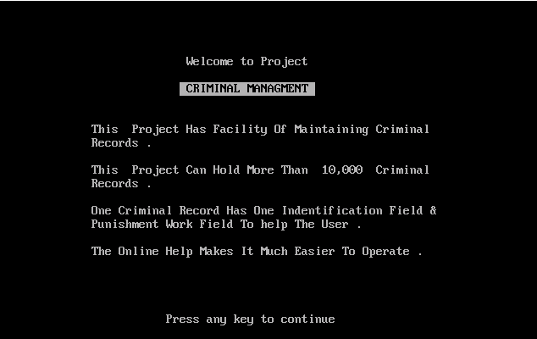

***Main Menue***

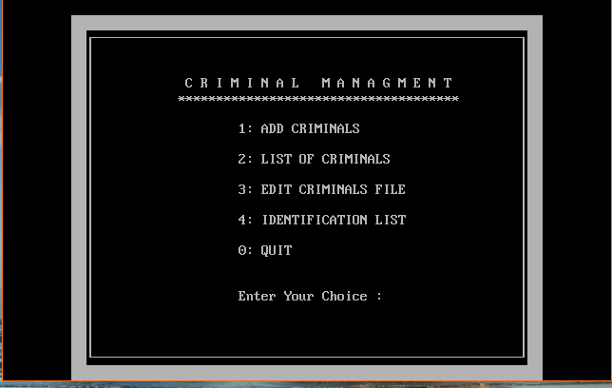

***Addition of the record***

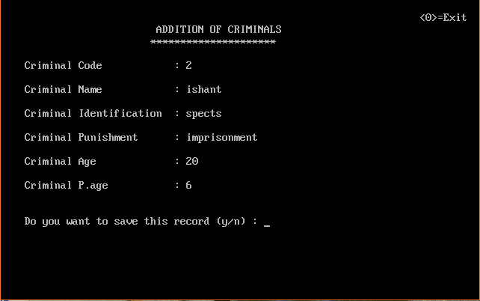

***List of criminals***

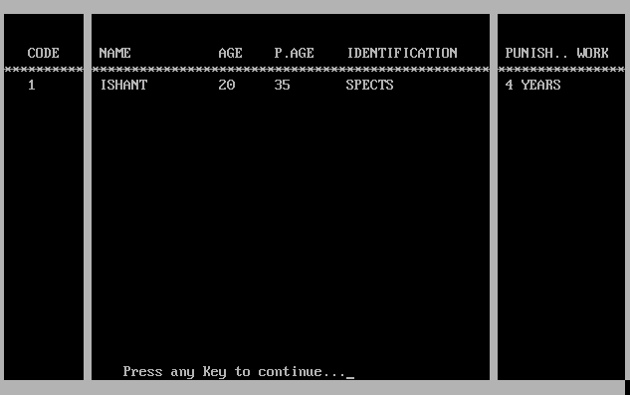

***Edition of criminal file***

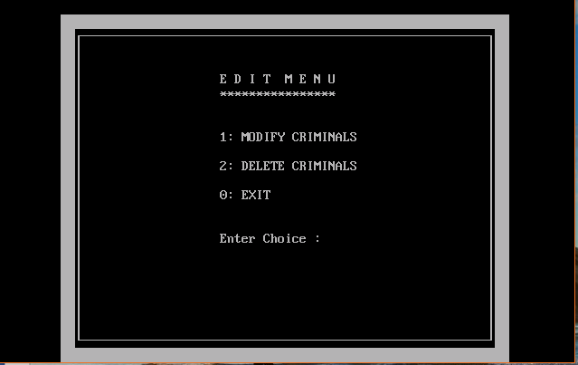

***\* Modification of the record***

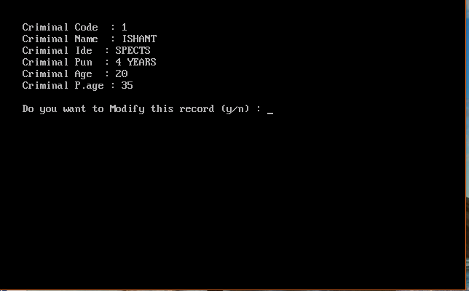

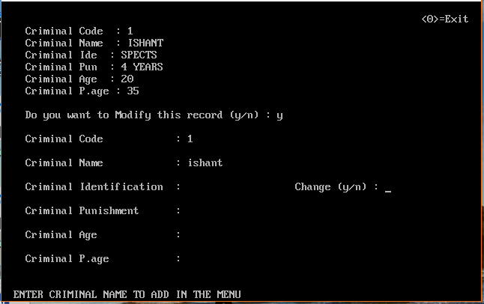

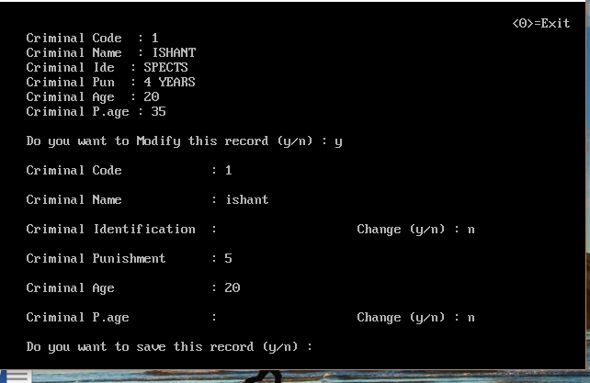

***\*Record modified***

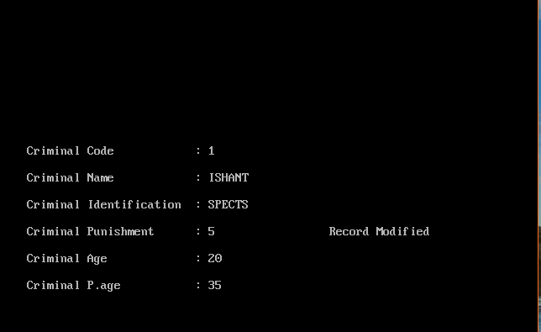

***\*Deletion of the record***

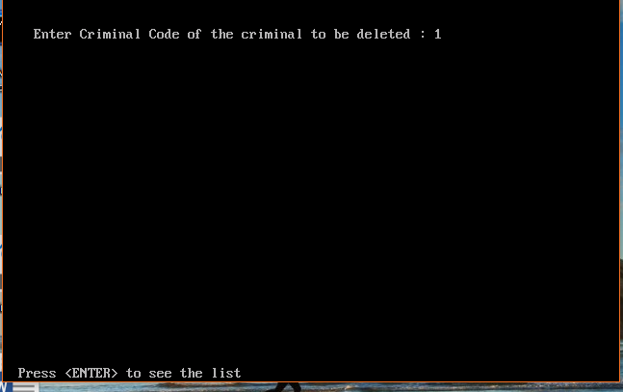

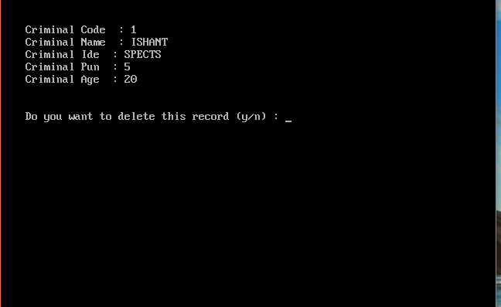

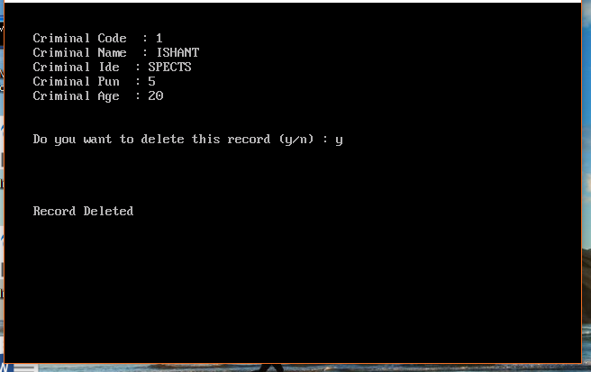

***Searching of the record***

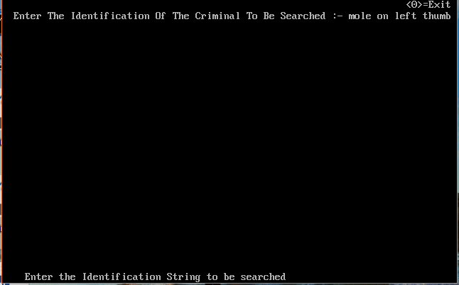

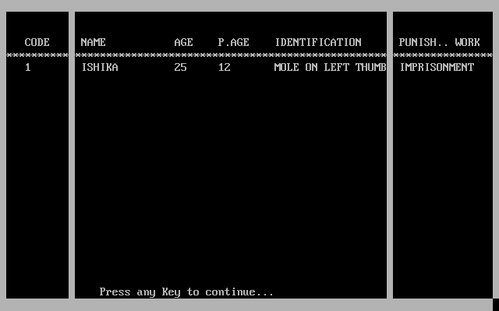

***EXIT***

